**GIT -HOL -2**

**CODE**

# Clone your GitLab repository

$git clone <https://gitlab.com/ashikam22cs-group/GitDemo.git>

# Go into the repo folder

$cd GitDemo

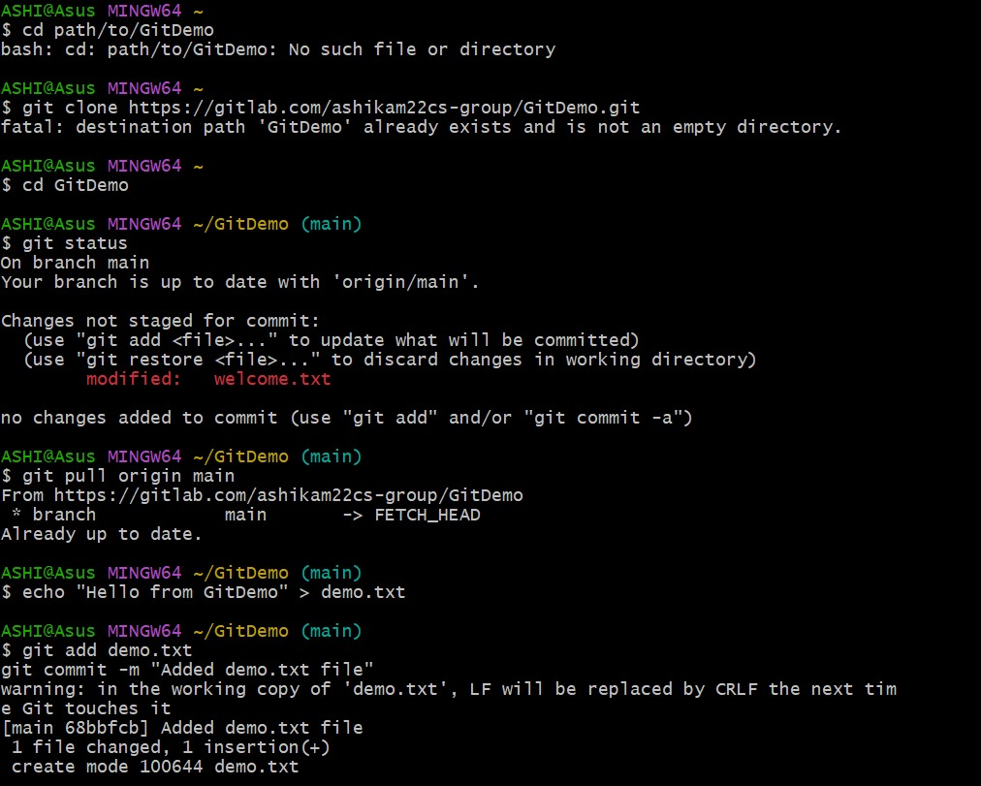

# Inside Notepad, type the following lines and save:

# (this will ignore any .log files and the log/ folder)

$*.log

$log/

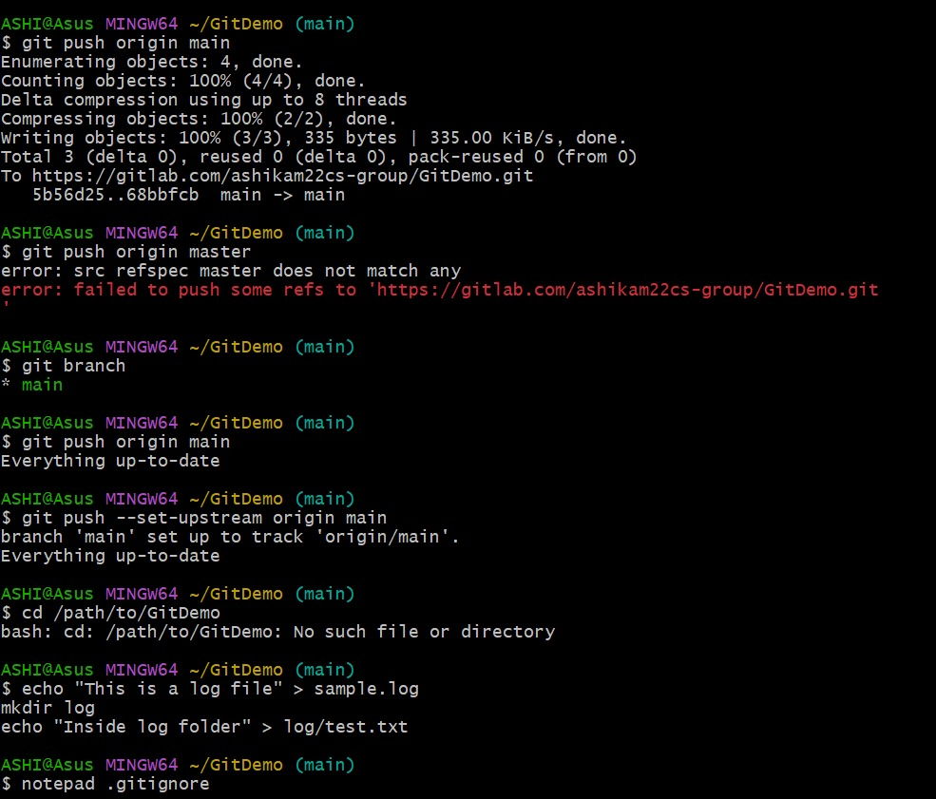

# Add .gitignore to staging

$git add .gitignore

# Commit the change

$git commit -m "Add .gitignore to ignore log files and log folder"

# Push the commit to GitLab

$git push origin main

